- BIOS And POST Troubleshooting Theory

- List 5 common BIOS or POST error messages and what issue each one points to?

Answer:
BIOS/POST Error | Hardware / Configuration Issue
- CPU Fan Error | CPU fan is not detected or not working
- CMOS Checksum Error | CMOS battery may be weak or BIOS settings were reset
- Keyboard Error / Keyboard Not Detected | Keyboard is disconnected or faulty
- No Boot Device Found | Hard disk/SSD is not detected or boot order is incorrect
- S.M.A.R.T. Status Bad | Hard disk/SSD may be failing

These are common POST/startup errors documented by motherboard and PC manufacturers.

- A PC beeps 3 times repeatedly and gives no display. What does it mean for AMI BIOS?

Answer:

For a traditional AMI BIOS, 3 beeps usually indicate a Base 64K memory failure, which means there may be a problem with the RAM.
Troubleshooting Steps:
- Remove and properly reseat the RAM in the memory slot.
- Try a known working RAM stick or test one RAM module at a time. AMI specifically recommends reseating or replacing memory for this beep condition.

- Access the BIOS setup utility on any available PC or virtual machine, take a screenshot of the main BIOS screen, and identify the motherboard manufacturer and BIOS version?

Answer:
I accessed the BIOS setup utility and checked the system information.
Motherboard Manufacturer: ASUSTeK COMPUTER INC.
Model/System: ASUS TUF Gaming A16
BIOS Version: FA607NUG.306
BIOS Mode: ASUS BIOS Utility – EZ Mode

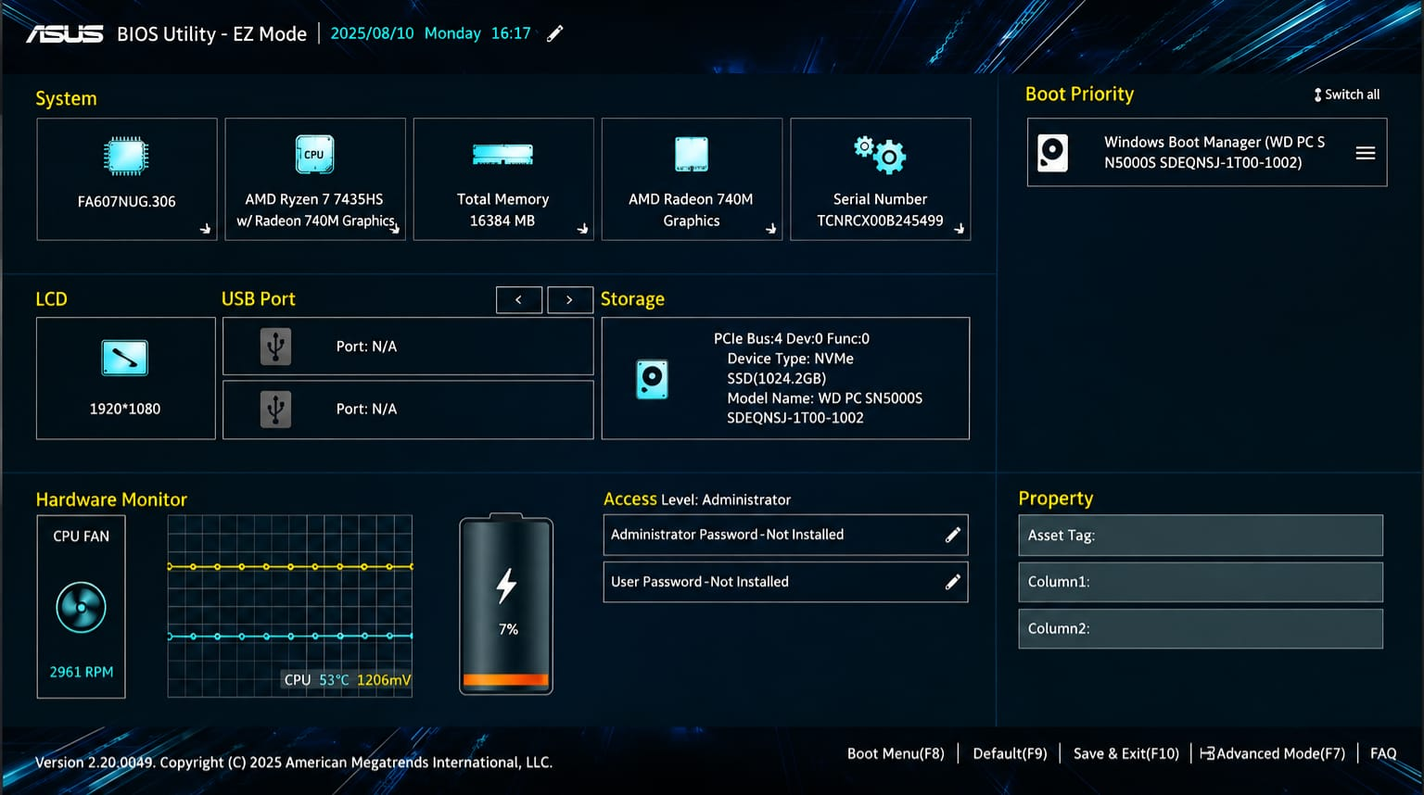

- You are given a screenshot of a POST error message that says “CMOS checksum error – Defaults loaded.” Explain what this means and describe how you would resolve this issue in a real system?

Answer:
This error means the BIOS could not read the saved CMOS settings correctly, so it loaded the default settings. This usually happens because the CMOS battery is weak or dead.

To fix it:
- Replace the CMOS battery if needed.
- Open BIOS and set the correct date and time.
- Save the BIOS settings and restart the PC.

